**Find websites that use typography as the major design element**

<http://enso.readymag.com/eames/>

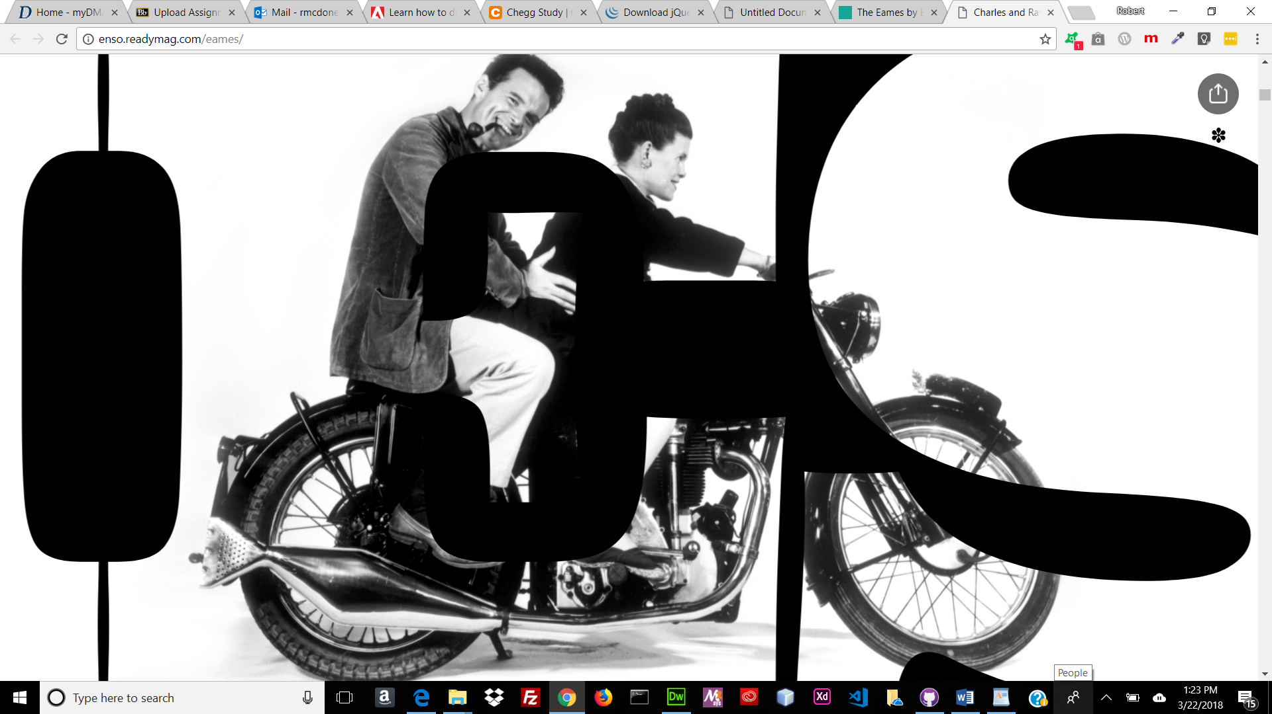

https://amessagefrom.earth/

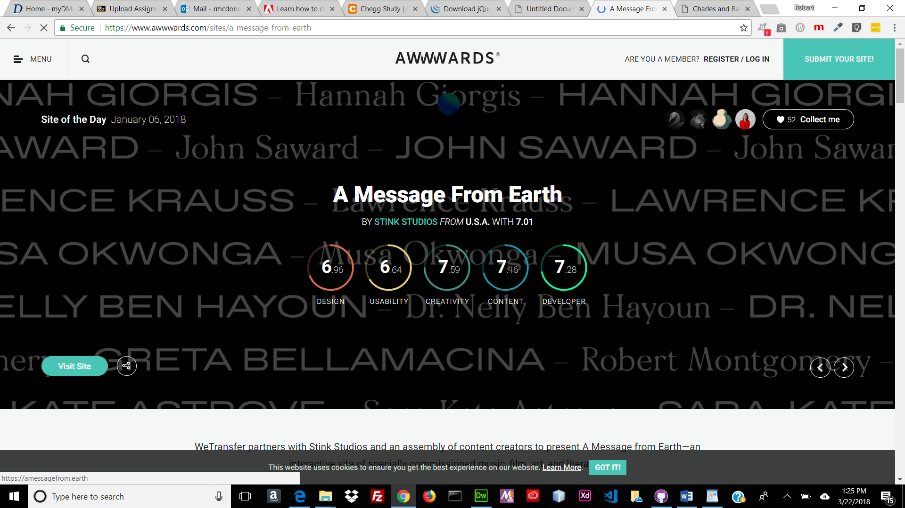

<https://listenfestival.be/>

